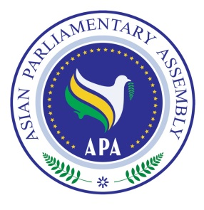
Asian Parliamentary Assembly

Standing Committee on Political Affairs
And
Meeting of SCCAP

29 October 2018
Gawadar - Pakistan

Draft Agenda

1- Adoption of the Agenda
2- Election of the Bureau
3- Report by H.E. Dr. Ali Khorram, Deputy Secretary General of APA on SCCAP and Political Resolutions
4- Opening Remarks by Chairman of the Senate of Pakistan (Chairperson of the Meeting)
5- Deliberation on the Asian Parliament
6 - Deliberation on Draft Resolutions
7- Any other matters.
8 - Report of the Meeting and Closing Session of the Standing Committee

As of 26 August 2018

